Data Analysis Project-1

● This dataset contains Dataset Overview details of the used cars in Germany which are on sale on e-bay.

* Dataset contain 260901 Rows and 19 Columns(features)

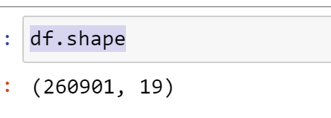

* 19 Features of Dataset are

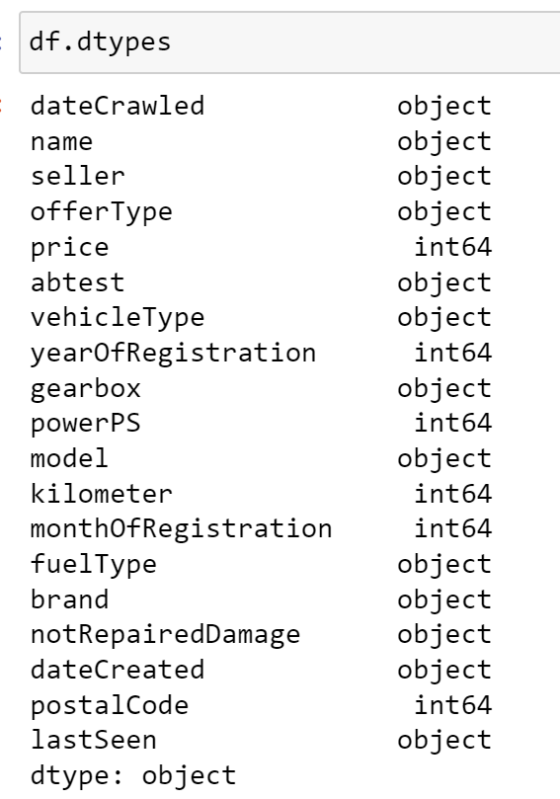

**Analysis 1**

**Distribution of Vehicles based on Year of Registration**

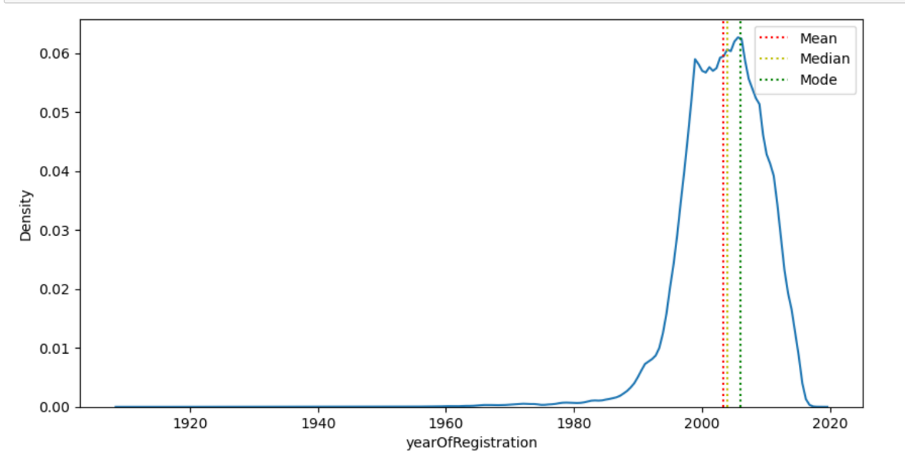

**Summary** :

Distribution of data is left skewed (negative skewness)

Most of vehicle are Registrated in the year 2006

- Mean of the distribution is 2004

- Median of the distribution is 2004

- Mode of the distribution is 2006

**Variation of the price range by the vehicle type**

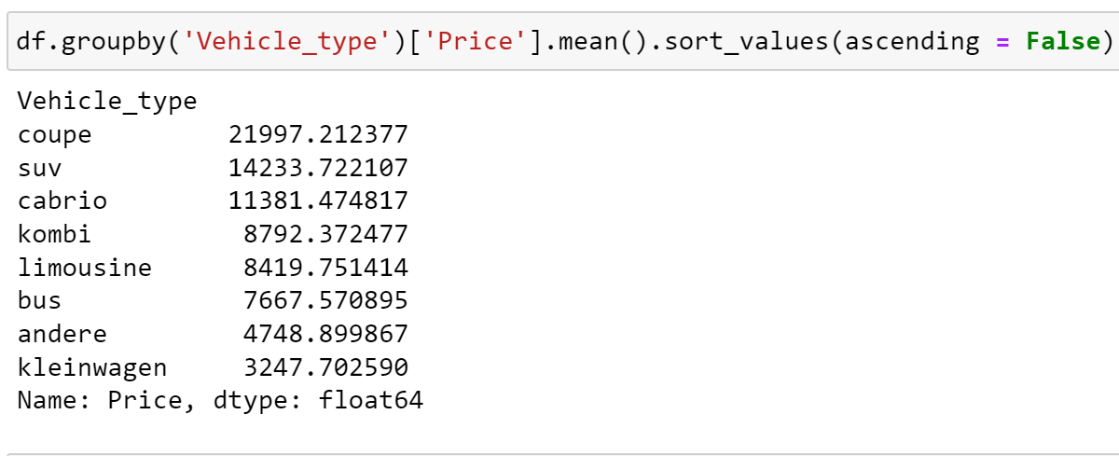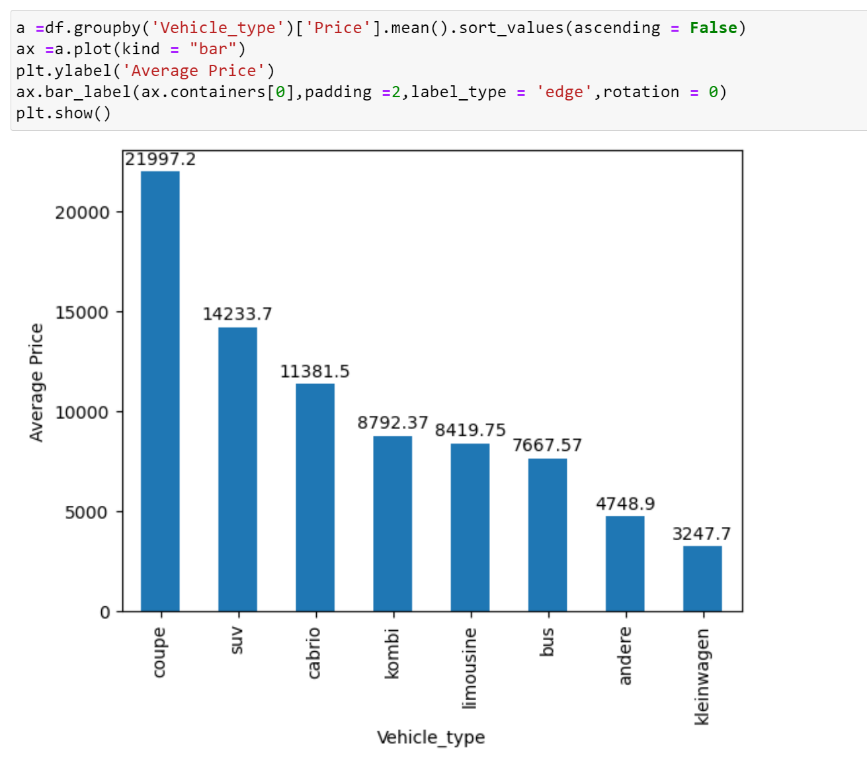

**Summary** :

Coupe Vehicle has high Average Price of **21997**

Kleinwagen Vehicle has low Average Price of **3247**

**Total count of vehicles by type available on e-bay for sale**

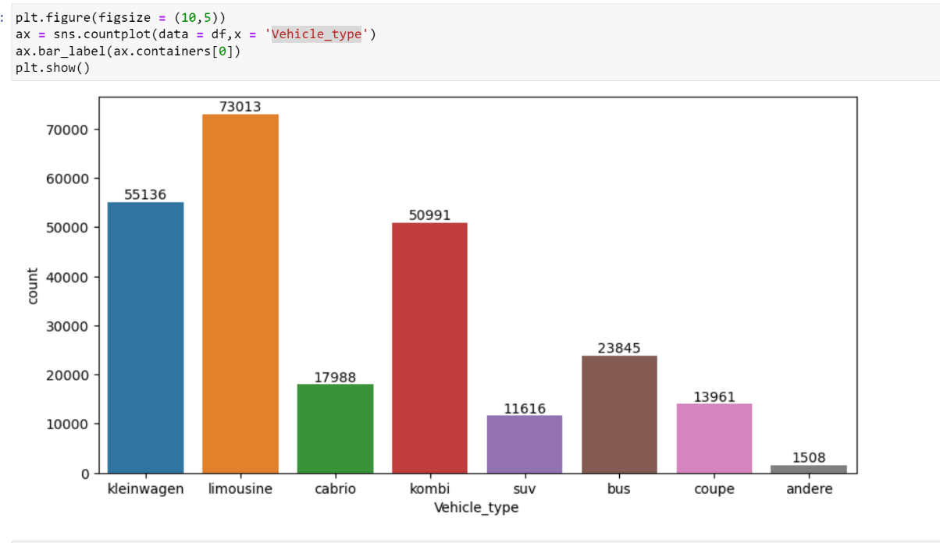

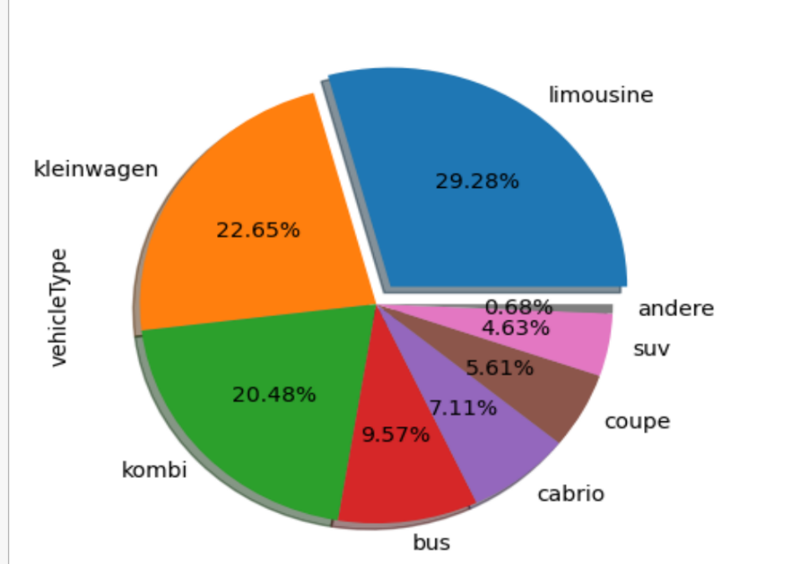

**Summary** :

From the above pie and bar plot ,

* **Limousine** vehicle-type is has high sale with 73013 of total sales i.e **29.28**% of sales
* **Andere** vehicle-type has less sale with 1508 of total sales i.e **0.6%** of total sales

**Relationship between Price and Kilometer**

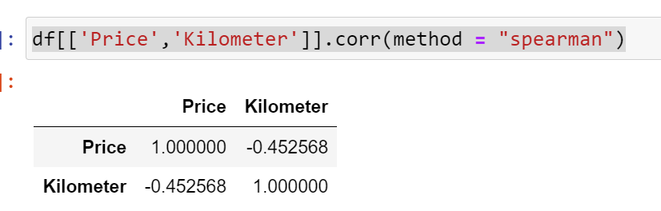

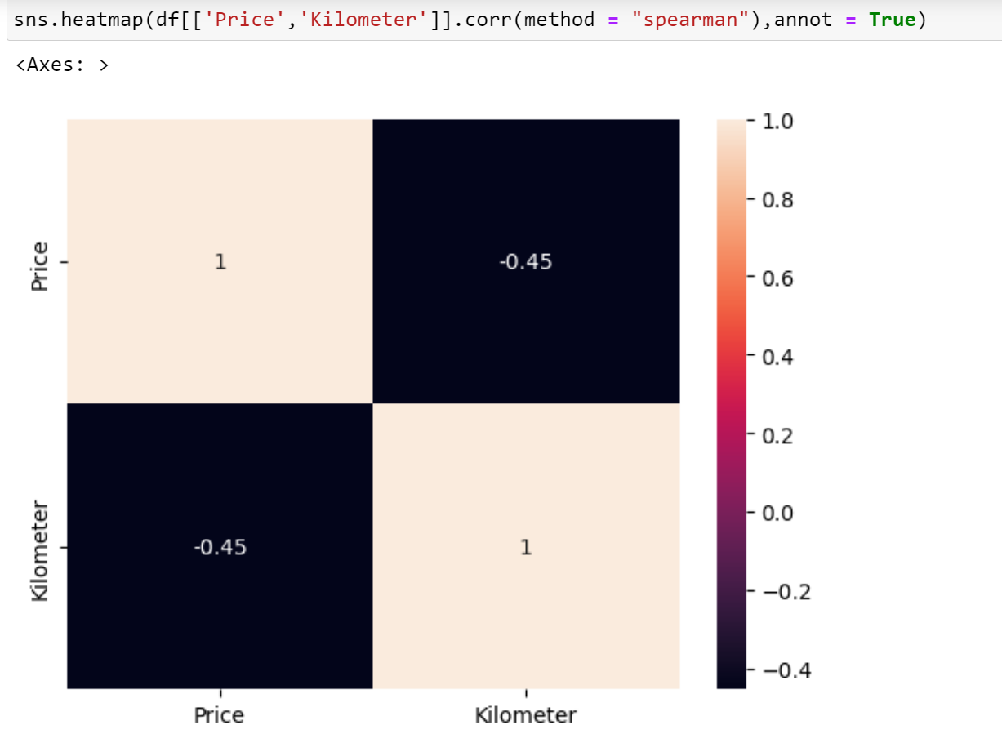

**Summary** :

* Heatmap are used to show the correlation between them.
* **A Spearman’s correlation** coefficient of between -.04 and -.06 indicates a **moderate strength monotonic relationship** between the Price and Kilometer.

**Analysis 2**

**No of Vehicles by Brand Available on e-bay for sale**

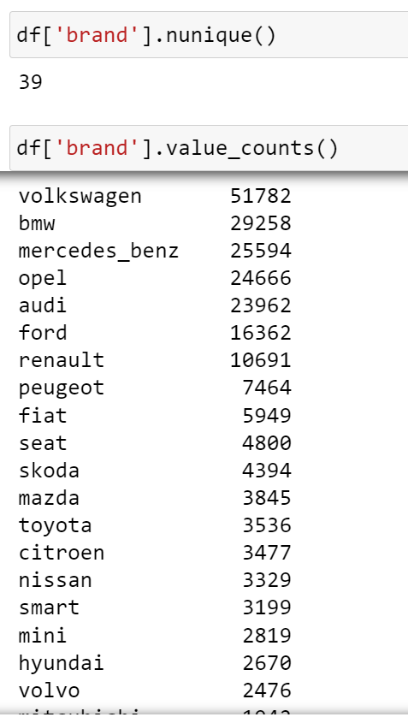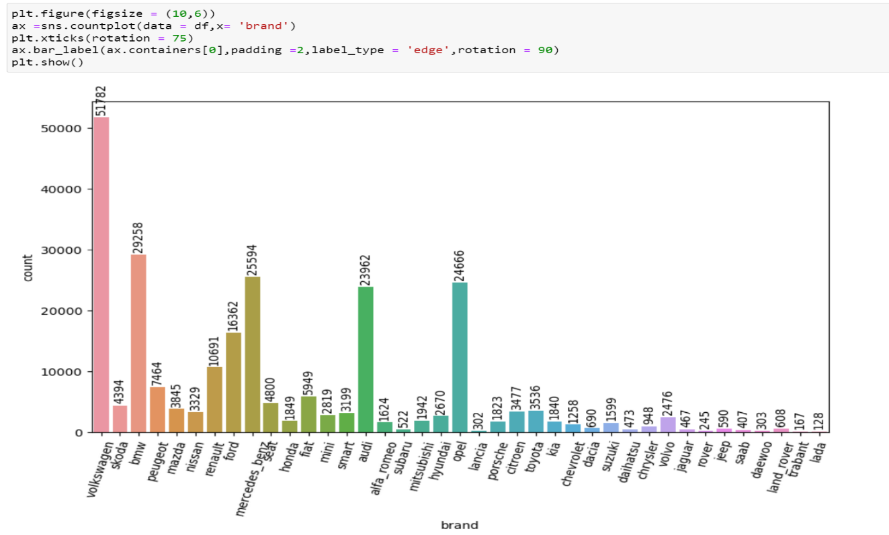

**Summary** :

Total Number of Vehicle Brands **39** available for e-bay sale

- **Volkswagen** has the high sale with the **51782** total sales

- **Lada** has the less sale with the **128** total sales

**Average price for vehicles based on the type of vehicle as well as on the type of gearbox**

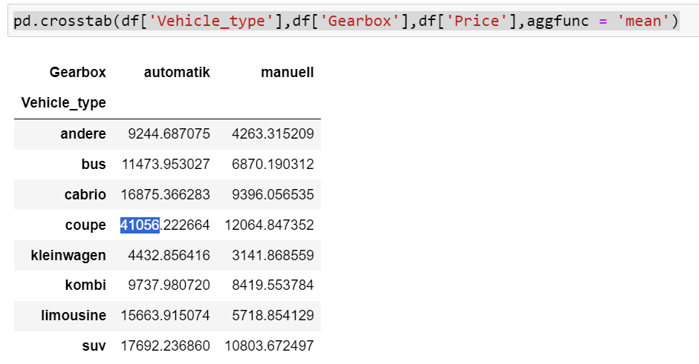

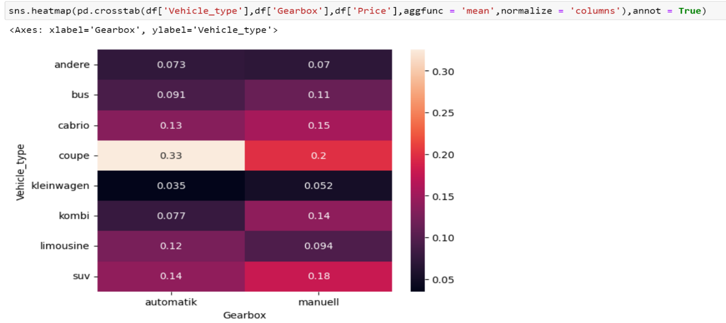

**Summary** :

* Coupe Vehicle-Type has high average Price of 41056 for Automatic and 12064 for Manual gearbox
* Suv Vehicle-Type has next high Average Price of 17692 for Automatic and 10803 for Manual gearbox
* Kleinwagen Vehicle-Type has low Average Price of 4432 for Automatic and 3141 for Manual gearbox

So, we conclude that Coupe and Suv vehicles have high Price for both Automatic and Manual gearbox compare to others . Kleinwagen vehicle has low Price in both Automatic and Manual gearbox

**Marginal probability of private seller**

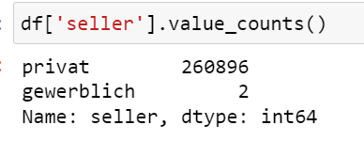

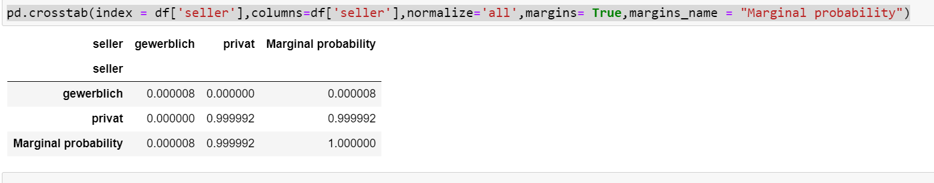

**Summary** :

Marginal probability of private seller is 0.999992

Here private seller is almost have e-bay sales compare to gewerblich sellers with values of 260896

**Analysis 3**

**The memory usage of the data is around 6.1 mb.How can we reduce the memory usage of the data set?**

**Solution –**

To optimize memory usage in Python, you can use memory-efficient data structures and algorithms, reduce the size of objects in memory, and minimize the use of global variables. You can also use profiling tools to identify areas of your code that use a lot of memory and optimize them

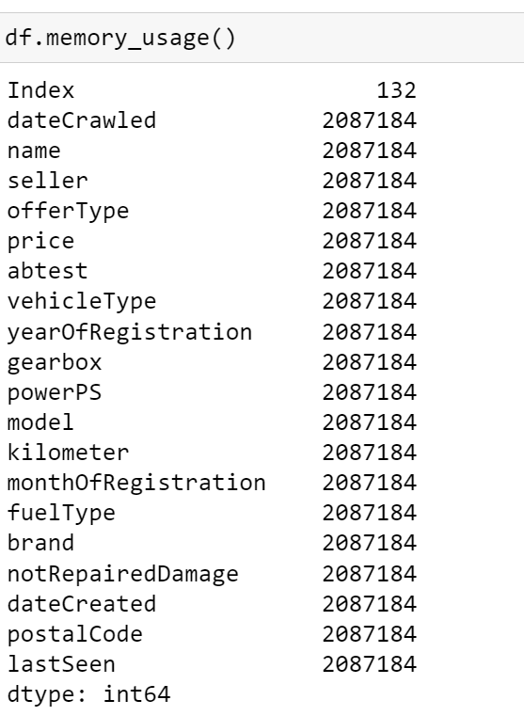

**Average price of vehicle by fuel type and gearbox type:**

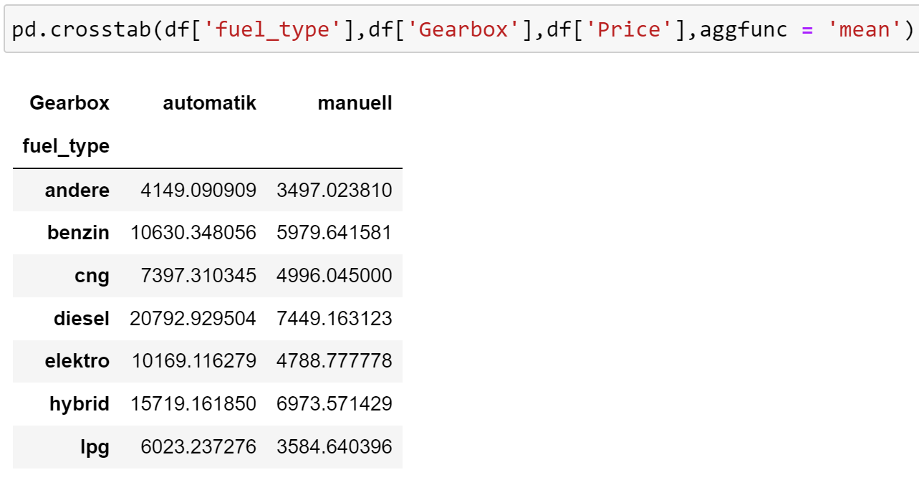

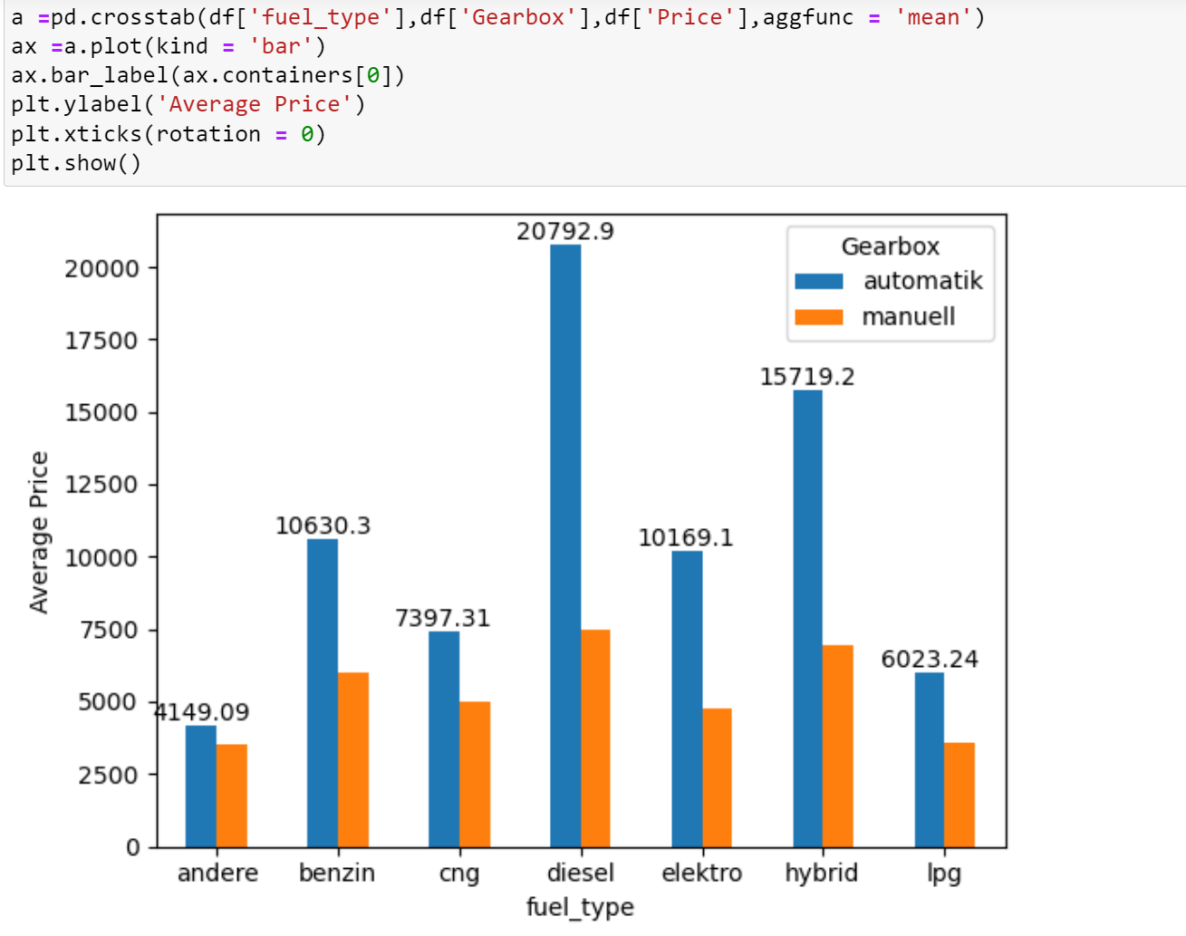

**Summary :**

- Diesel fuel-type has high Average Price of 20792 for Automatic and 7449 for Manual gearbox

- Andere fuel-Type has low Average Price of 4149 for Automatic and 3497 for Manual gearbox

So, we conclude that Diesel fuel-type vehicle high Price for both Automatic and Manual gearbox compare to others . Andere fuel-type vehicle has low Price in both Automatic and Manual gearbox

**Average power of a vehicle by vehicle type and gearbox type :**

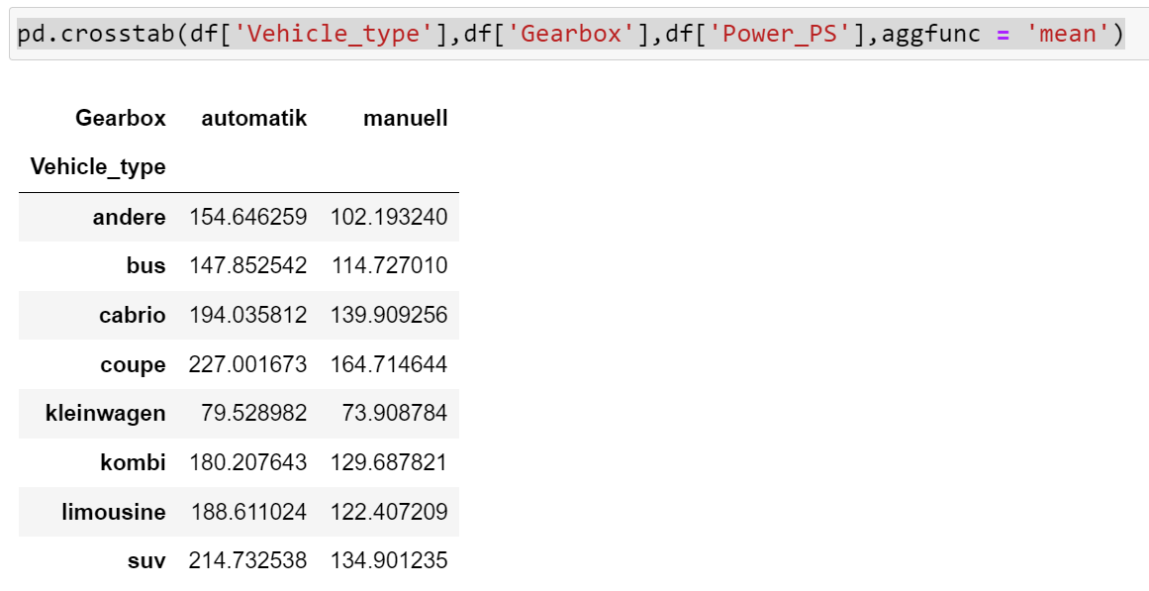

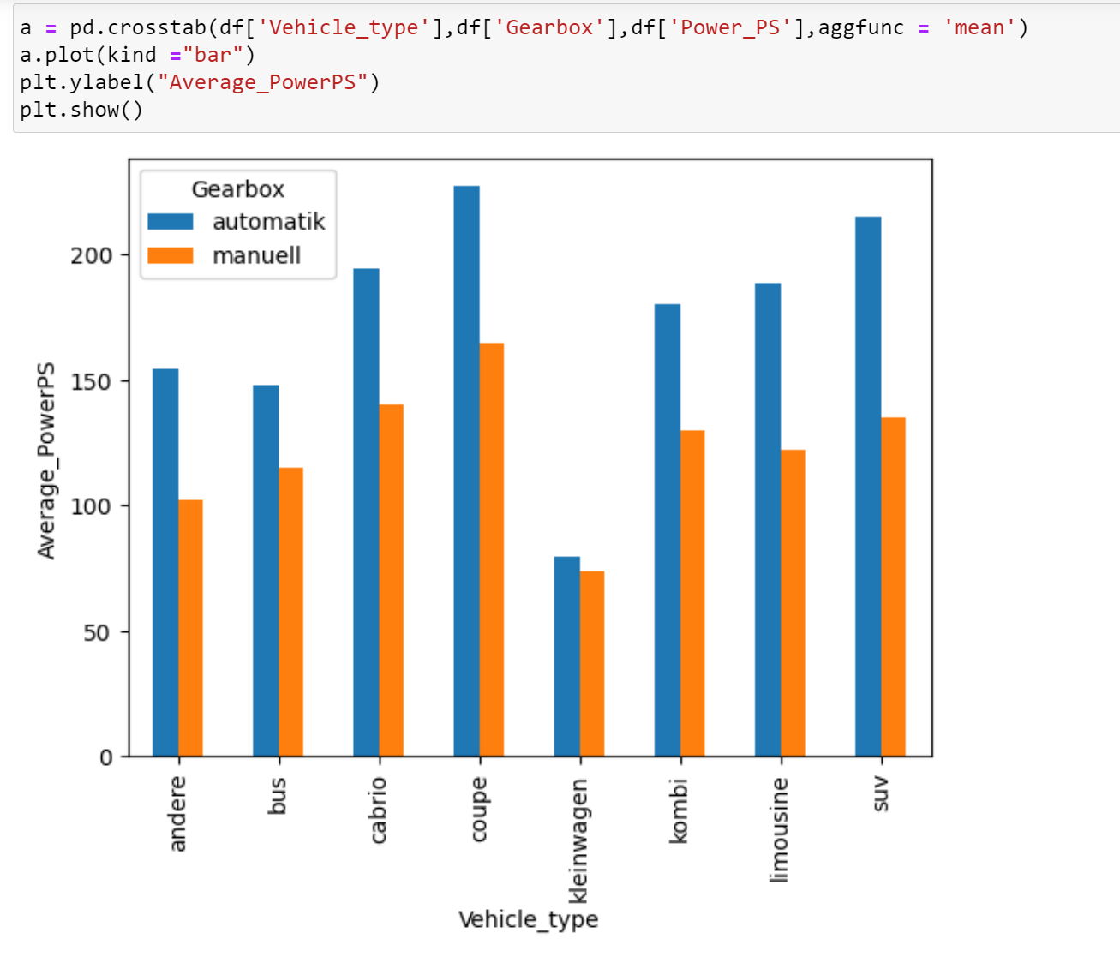

**Summary :**

**-** Coupe Vehicle-Type has high average Power of 227 for Automatic and 164 for Manual gearbox

- Suv Vehicle-Type has next high Average Power of 214 for Automatic and 134 for Manual gearbox

- Kleinwagen Vehicle-Type has low Average Power of 79 for Automatic and 73 for Manual gearbox

So, we conclude that Coupe and Suv vehicles have high Price for both Automatic and Manual gearbox compare to others . Kleinwagen vehicle has low Price in both Automatic and Manual gearbox

**Average price of a vehicle by brand as well as vehicle type :**

